# How to start dev Report

## configuration data base table

### change database char set to utf8

alter database {your database} character set 'utf8';

alter column {your column} character set ‘utf8’；

### database init

insert into basi_report_type_info value('00001','现金类报表','00');

insert into basi_report_sub_type_info value('00001','实时类报表','00001');

insert into basi_report_info value('00001','00001','BOM交易明细报表','00','OperatorId|StationId|CardIssuerId');

## Match rule for Report General

Must be as the same as database hierarchy and excel file name must be the same as the value **Report_Name** column.

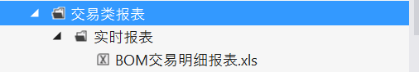

## How to set query condition

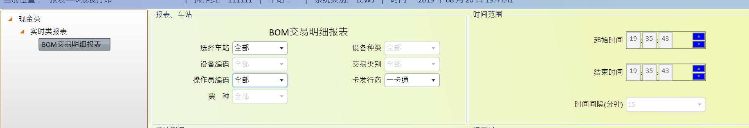

Database setting like below

'OperatorId|StationId|CardIssuerId’

Query condition